Getting started

Powering on
Before switching on check that Safety Requirements are observed. Connect the power cable to the AC power connector on the rear panel and switch on AC mains power switch on the front panel. The welcome page will appear (Fig. 1) and a self-test procedure will be performed which detects the installed modules and diagnoses any error conditions which could inhibit normal operation.

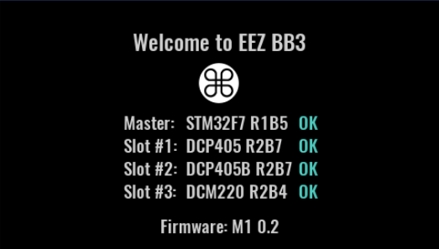Fig. 1: Welcome page (light color theme)
On the first power up all channel outputs are turned off to prevent any connected load from being damaged unintentionally.

The channel output state at subsequent power-ups will depend on what is defined in the selected user profile. A special option in System settings can also be set which overrides the state set by the particular selected user profile.

The default display view is numeric and the default color theme that dark. Both can be changed. The home page of the 4-channel configuration example is shown in Fig. 2:

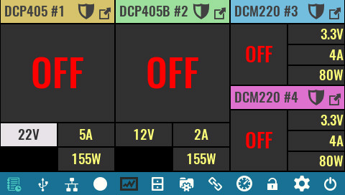Fig. 2: Home page on first start

Switching off and standby mode
The EEZ BB3 offers two options to switch off / power down: using AC power switch on the front panel or entering standby mode. In both cases all installed modules are disconnected from AC power. In standby mode the MCU module remains powered (as indicated by the Standby indicator on the front panel). Fig. 3 shows the user interface prior to entering Standby mode and the info message that is fading out. To resume normal operation from standby mode, tap any part of the display and wait a moment for the power-up procedure to complete.

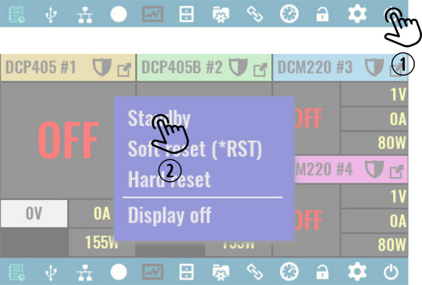Fig. 3: Entering standby mode
SCPI
SYSTem:POWer OFF

Basic operations

Turn channel output on and off
Turn channel on (OE on)  Turning the channel output on is performed by taping anywhere inside the main channel display area.  The changed output state is indicated by display of the measured output values instead of “OFF”.  SCPI  OUTPut ON  OUTPut ON, <channel> | 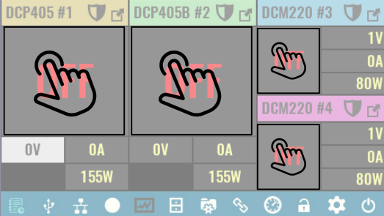
Turn channel off (OE off)  Turning the channel output off is performed by taping anywhere inside the main channel display area. The content of that area will be replaced with “OFF”.  SCPI  OUTPut OFF  OUTPut OFF, <channel> | 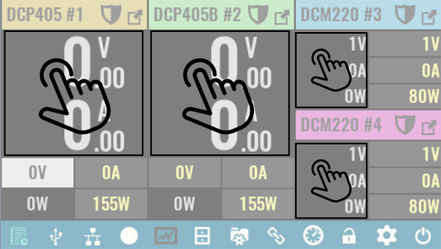

Set channel output values
Channel output values can be set regardless of the currently selected display view and channel output state as long as a trigger mode is not active (i.e. channel’s trigger is set to Fixed).

When an output parameter is highlighted (as in the figure below), its value can be set using the encoder knob on the front panel. By default the encoder switch is set to switch to the next parameter when pressed. That parameter will then have it’s background area highlighted to show it is now selected.

❑ | Set output voltage  Tap inside the voltage area of the channel secondary display area. If it is already selected (as shown), a keypad will appear as described in Data input methods.  The voltage set here is the max. output voltage when channel is in CV mode.  SCPI  VOLTage <voltage> | 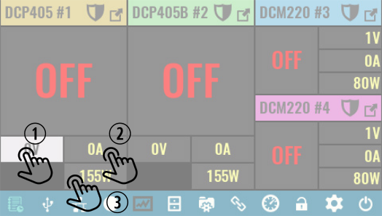
⬥ | Set output current  First tap the current area of the secondary channel display. A second tap is required if this option was not selected previously (as in the above example).  The current set here is the max. output current when channel is in CC mode.  SCPI  CURRent <current>
 | Set output power limit  Follow the above described procedure.  Note that when a power output limit is set, the product of the set voltage and set current is used to calculate the output power limit rather than the voltage/current actual measured output values. For example, if power limit is set to 100 W (DCP405) then set current cannot exceed 2.5 A for a max. voltage of 40 V. Similarly the output voltage cannot be set above 20 V if max. current is selected as 5 A even if the actual measured output current with a connected load is well below the set limit.  SCPI  POWer:LIMit <power>

Data input methods
There are three touch-screen methods of entering data - in addition to the physical rotary encoder on the front panel. Two of those methods (Step and Slider) can be used in non-confirmation (default) or confirmation mode or in combination with the encoder knob. All data input methods are accessible from the same popup menu that has the three methods shown as tabs on the right side.

Keypad |  | 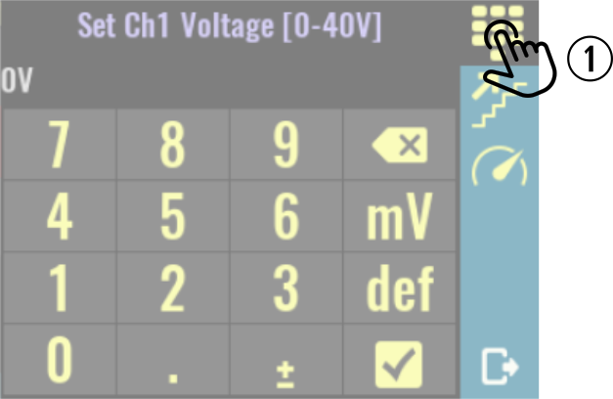
❑ | This is the default data entry method, and in case that another one is currently selected it can be selected again by tapping on its icon.  When selected, simply enter new numeric value for the parameter that is displayed in the header (Ch1 voltage in this example).  You can also select unit of measurement if more then one is available (e.g. mV and V for voltage).  This data entry method always requires confirmation.
Step |  | 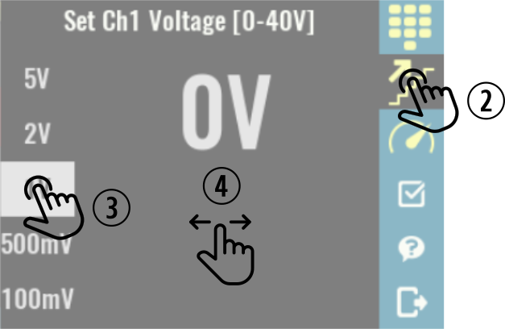
⬥ | Tap on step method icon.
 | Select step value.
❒ | Increase or decrease set value of the selected parameter in selected steps. If encoder knob is used the selected parameter value will be changed for in selected step increments (1 V in this example).
Slider |  | 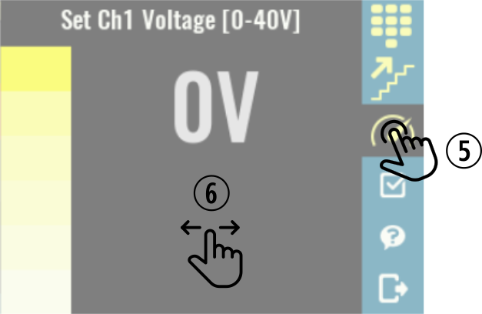
⧫ | Tap on slider method icon.
 | Increase or decrease set value of the selected parameter.
Confirmation mode |  | 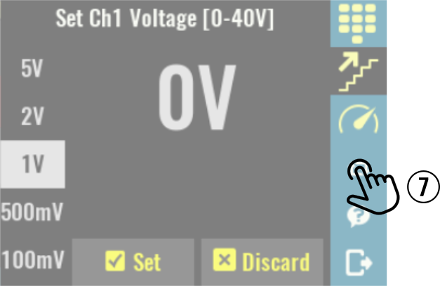
◆ | Tap to enable or disable confirmation mode, which will show on the bottom of the screen. Confirmation mode can be used in Step and Slider input modes only.  When enabled, confirmation mode blinks the current value of the setting until it is confirmed with Set option, at which point the new value becomes effective. The new parameter value can be reset to the previous value using the Discard option.

Accessing channel protections and settings
The EEZ BB3 firmware includes comprehensive control of each power module and the feature list goes well beyond the basic operation of setting and displaying output parameters. Other channel specific functions are shown in the Protections and settings page.

The channel Protections and settings page can be reached whenever the channel is in regular or maximized view.

Note that if any of channel’s protection modes have tripped, the tapping the Protection icon will take you to the Clear / Disable protection page – regardless of whether the channel is in regular of maximized view.

❑ | Access protections and settings in regular view  Select the channel whose settings you want to change and tap on its Protection icon.  A new page with channel’s protection section and channel settings will be displayed.  Availability of certain options depends on the channel mode (e.g. when channel is in tracking or coupling mode Calibration is disabled) and capability (e.g. for example the DCP405B and DCM220 modules do not have any Advanced options. | 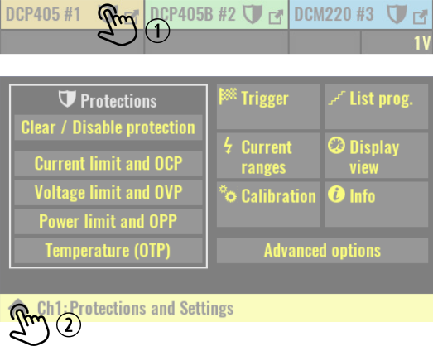
⬥ | Exit Protections and settings page.
 | Access protections and settings from maximized view  If channel is in regular view, tap on the channel’s Maximize icon. | 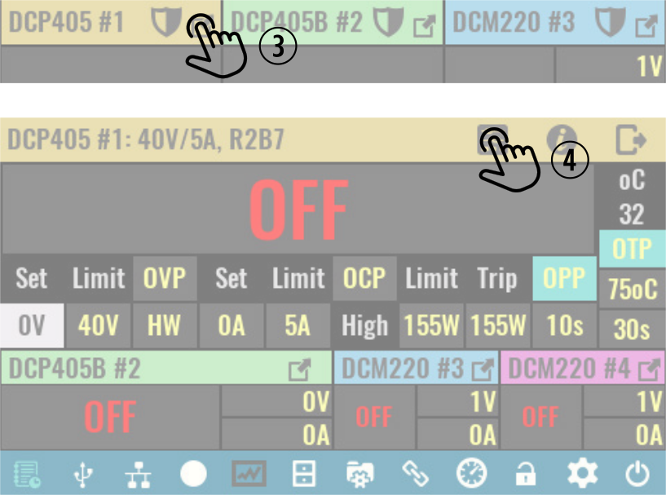
❒ | Tap on its Protection icon.

Accessing system settings

❑ | Tap on System settings icon on the status bar.  The number of available options depends of firmware version.  When System settings page is displayed it is still possible to check channel’s output state and values (e.g. in this example all outputs are turned off). | 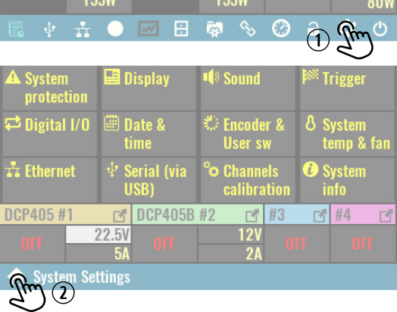
⬥ | Exit System settings page.

